GlobalSight Automation-User Guide

This doc is used to guide how to run the GS automation with Selenium automation Frame Work.

Contents

GlobalSight Automation-User Guide 1

Setup Developing Environment 2

Server and Firefox Configuration 4

Preparation before run automation test 9

Properties File 9

GlobalSight Server 10

Run Automation 11

Coding 11

# Setup Developing Environment

1. Install the JDK with the latest version.
2. Download the Eclipse classic version and extract it.
3. Install the TestNG in the eclipse.
4. In the eclipse, click “help->software updates”.
5. Click “Available Software->Add Site”, input the <http://beust.com/eclipse> in the “Location” input box.
6. Click “OK”, select the “testng” and follow the prompt.
7. When finished, restart the eclipse.
8. Repeat above step to install m2e. (If don’t so clear how to install maven, please search from internet.)

After installation, it’s like below screen.

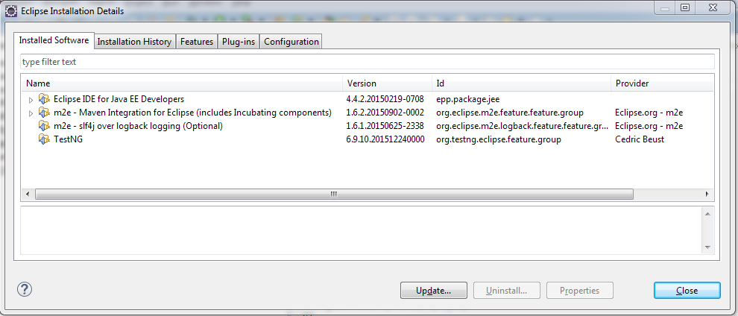

1. Copy the selenium folder “selenium-java-2.48.2.zip” to the plugins folder and unzip it. (\\10.10.213.1\gsimage\Tools\Selenium)
2. Add the selenium client jars to the project “Build Path”.
3. Login to Gitlab Server, checkout selenium kit - http://10.10.213.165/erica/selenium
4. Create a new project in Eclipse(File->New->Java Project), input a name and point the location.

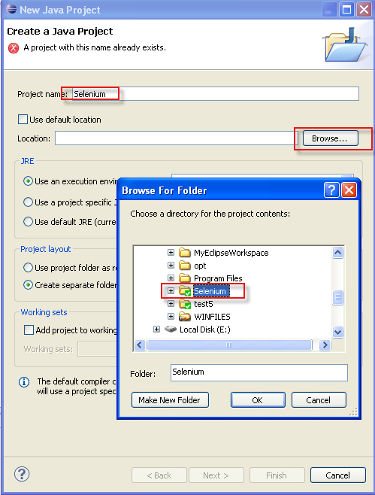

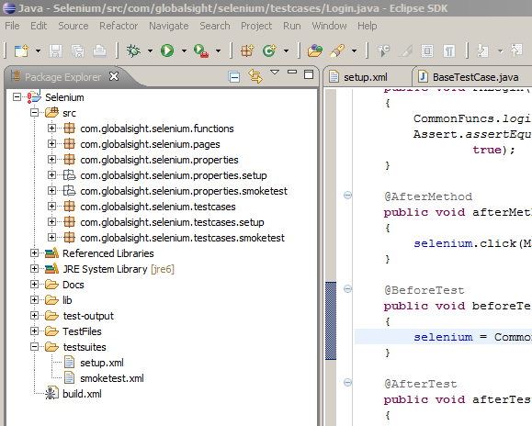

1. Explanations about kit structure –

\src\com\globalsight\selenium\functions - including the function for features

\src\com\globalsight\selenium\pages – including definition for all elements in the webpage

\src\com\globalsight\selenium\properties – including user input data, eg, name, type ..

\src\com\globalsight\selenium\testcases – including all the test cases

\test-output\ - generate the result report of automation

\ GlobalSight Automation Files\ - including all the test files and test results in test case

\testsuites\- including 5 xml files to cover different testing processes.

1. smoketest.xml – including the test cases about the basic operations, such as new, edit, remove…
2. prepare.xml – including test cases which do some preparing operations for job testing.
3. Reports.xml – including all reports test cases.
4. JobandCVS.xml – including the job-related test cases as well as CVS related testing.
5. TestMatrix.xml – including test matrix cases.

\build.xml\ – entry of automation test. User can right click the “Build.xml” and select “run as->Ant Build”. User can also decide running order and test suites in this xml file.

# Server and Firefox Configuration

**Notes:** It’s recommended to run the testcases with firefox 3.x

1. Install Firefox version 39.0. If the version is too high, the automation kit would not be run smoothly.
2. Copy the selenium folder “selenium-2.0b3.zip” to the one system (where you want to run automation) folder and unzip it. For example(C:\selenium-2.0b3)

Copy the directory “GlobalSight Automation Files” to the system, for example (C:\GlobalSight Automation), and share the directory, the files in this directory are used for running automation.

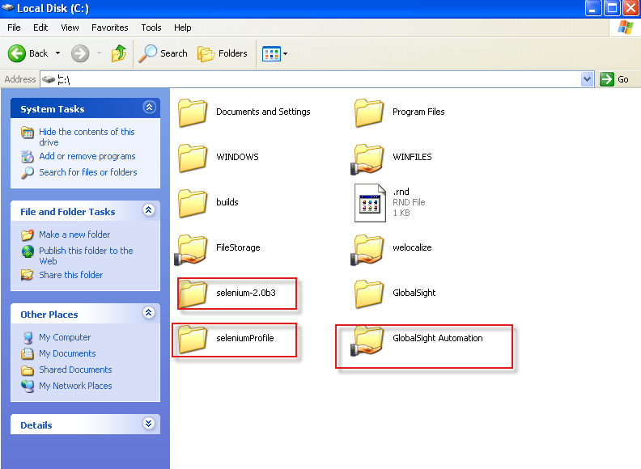

1. Open “cmd” command, navigate to firefox installation directory, and input “firefox -p”

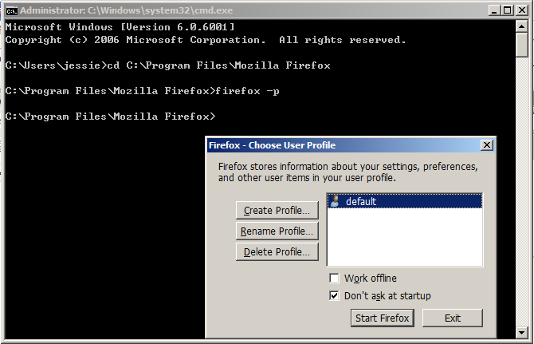

1. Click Create Profile…

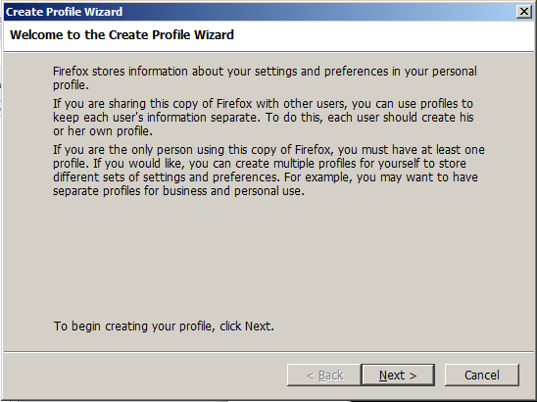

1. Click Next, Input a new profile name, like “selenium”. Select a file folder for example(C:\seleniumProfile) and Then Click Finish

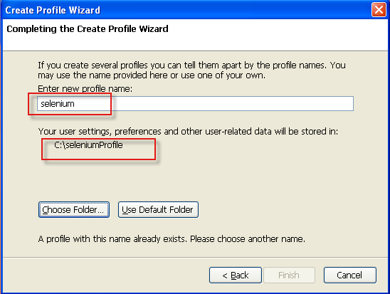

1. Click Start Firefox with newly created firefox profile.

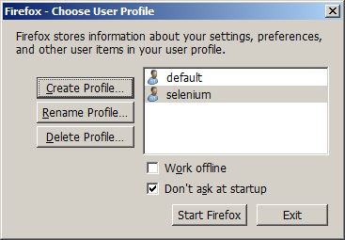

1. Set the default download location with options –

“Save files to” is the folder you created in step 1

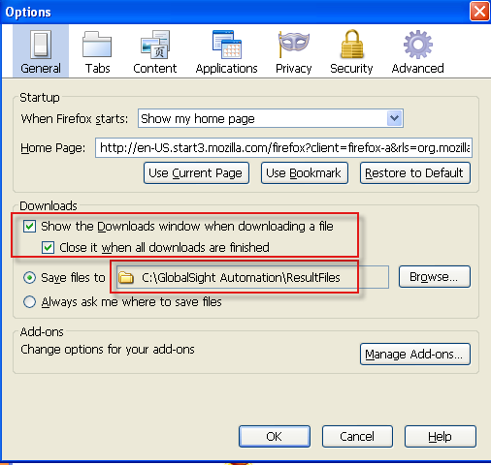

To make sure Firefox could download file without any dialog, you should make the configurations as below:

Log one GlobalSight Server and export some file, set the options like

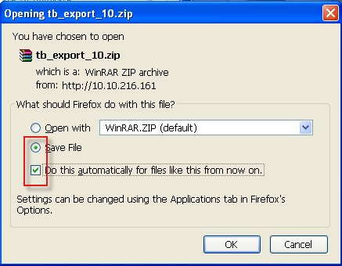

This operation must be done for all the downloaded format files in our automation test case.

Make sure all downloaded file format listed in the Applications with Save File. Like below

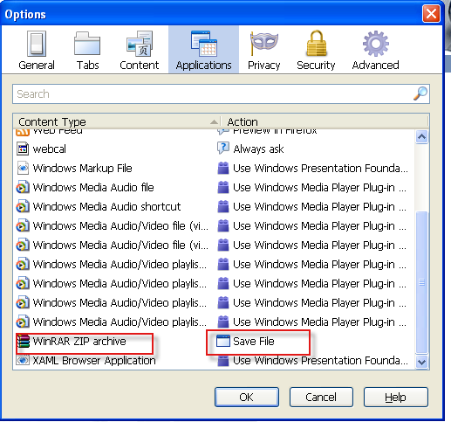

After that, you can close firefox.

1. Run the server.

Run the command “cmd”, the run the command as below:

“java -jar <Server Path> -firefoxProfileTemplate <firefox profile path> -port <port>”

**For example:**

java -jar selenium-server-standalone-2.48.2.jar -firefoxProfileTemplate C:\seleniumProfile -port 3333

# Preparation before run automation test

### Properties File

1. “\src\com\globalsight\selenium\properties\ConfigData.properties”, this properties file is very import, you must specify the server ip as well as the company name, for example:

######################System configuration######################

######GlobalSight Server############

SERVER_URL = http://10.10.216.161:80

######SELENIUM Server###############

SELENIUM_HOST = 10.10.216.161

SELENIUM_PORT = 3333

######Base_Path:save the test files, the directory is in SELENIUM Server######

Base_Path = \\\\10.10.216.161\\GlobalSight Automation\\TestFiles\\

######Base_Path_Result:save the result files from GlobalSight(i.e. TB export files), the directory is in SELENIUM Server########

Base_Path_Result = \\\\10.10.216.161\\GlobalSight Automation\\ResultFiles\\

######BROWSER:Browser type to run automation######

BROWSER = *firefox

######other configuration############

……

COMPANY_NAME=913

admin = 913admin 913admin

pm = gs913pm gs913pm

anyone = 913anyone 913anyone

SUPERADMIN_LOGIN_NAME = superadmin

superadmin_password = password

admin_login_name=913admin

admin_password=password

pm_login_name = gs913pm

pm_password = password

anyone_login_name =913anyone

anyone_password = password

1. Other properties need to edit according to your test need

src\com\globalsight\selenium\properties\smoketest\CreateProject.properties (pm user info)

\src\com\globalsight\selenium\properties\smoketest\PrepareCreatingJob.properties (pm user info and new user info)

……

### GlobalSight Server

1. It is recommended that **re-creating** GS database before testing a new build. Because some cases contain superusers’ operation. If tester do not recreating GS database, it may lead to some failure related to super user operation. Besides, same job name cannot be created twice even in different company.
2. Create a new company manually, and change related information in the “ConfigData.properties” file.
3. Manually create a workflow, in which the first activity is “Translation1” and the second activity is “Review_linguistic1”. Export this workflow and save it with the name of “testwf.xml” under “GlobalSight Automation Files\TestFiles\importworkflow”.

# Run Automation

1. Change the testng.xml file if you want to configure the test cases information.
2. In Eclipse, right click the “TestMatrix_DataSource.xml” file and select “run as🡪 TestNG Suite”.

Or you can right click the “Build.xml” and select “run as->Ant Build”.

Also, debug is ok.

1. You can check the result at the “test-output” folder.
2. All cases are listed in “selenium_testcase.xlsx” on below \\huanghe\EG_Exchange\Ambassador\Selenium QA automation\Kit preparation
3. This automation script kit cannot be done unattended for many reasons, e.g. automation testing frame, script running, script quality, abnormal testing environment, tested system panics or hangs, incapable of refurbishing the test environment.

# Coding

1. Naming rules：
2. Add a suffix “BUTTON” to Button definition. Such as “OK_Button=’ok’”.
3. Add a suffix “MENU” or “SubMenu” to menu definition.
4. Add a suffix “CHECKBOX” to Check Box definition.
5. Add a suffix “RADIO” to Radio Button definition.
6. Add a suffix “TEXT_FIELD” to Text Field definition.
7. Add a suffix “TEXT” to Text Box definition.
8. Add a suffix “LABEL” to Label definition.
9. Add a suffix “SELECT” to select definition.